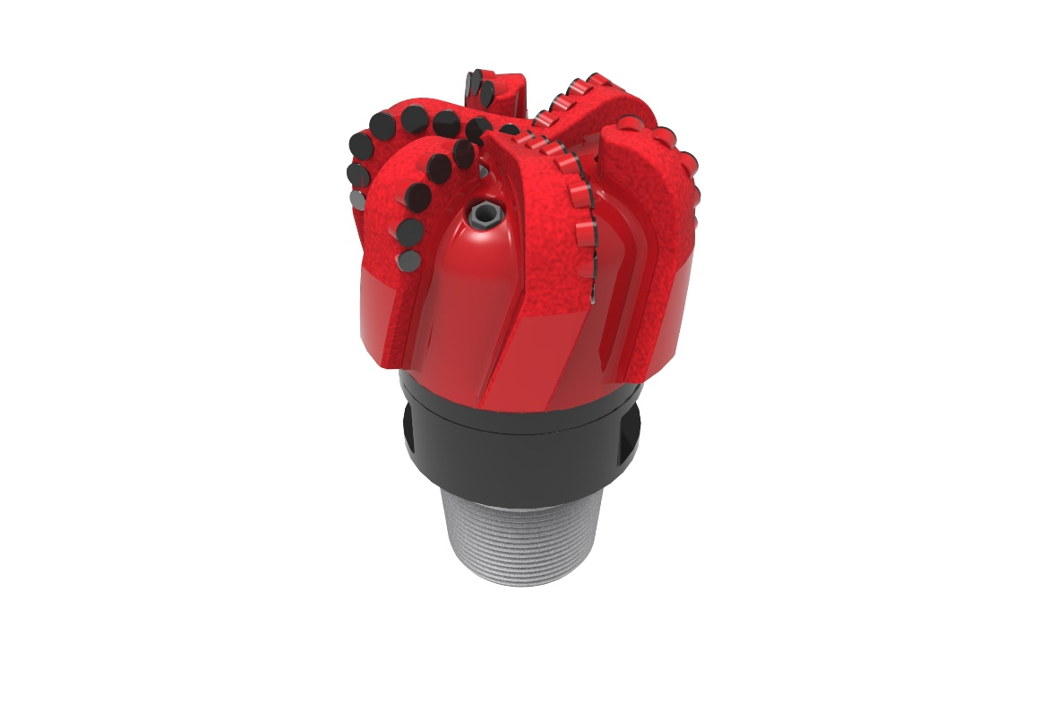
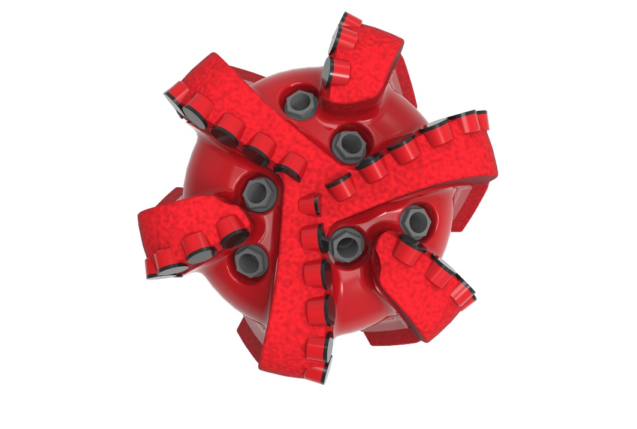

Drill Bit Specifications:
Cutter Size (Primary, Sec) | 3/4” , 5/8”
Cutter Count (Total, Gage, Back Ream) | 32 , 7
Blade Count | 6
Gage Length (Inches) | 3.00
Nozzle Count (Primary, Sec.) | 6
Nozzle Series (Primary, Sec.) | 60
JSA (Sq. Inches) | 17.60
Max. TFA (Sq. Inches) | 1.49
Operating Parameters:
Max. Weight on Bit (1,000 Lbs.) | 50
Make-up Torque (ft/lbs) | 40,563
Nominal Dimensions:
Overall Length (Inches) | *16.00
Make Up Length (Inches) | *11.12
Bit Breaker | SKB-21011
Connection | Ø6-5/8" API Reg.
Approx. Weight (Lbs.)  *Long tool joint available upon request (adds 6” to fishing neck, makeup and overall length, and 64 lbs. to approximate weight). | *165



Taylor-Made Features:

- Premium grade cutters maximize ROP and Life
- Nozzle configuration and large open face volume optimize blade cleaning and cuttings removal

619-SR Nomenclature Explained:

• | 6 | = | Number of Blades
• | 19 | = | Primary Cutter Size (19mm)
• | SR | = | Single Row

